Familiarity enhances coordination and efficiency in complex collective tasks

Marcelo Araya-Salas^{1,2}, Damien R. Farine³, Holger R. Goerlitz⁴, Nazareth Rojas-Rojas⁵, Silvia Chaves-Ramírez⁶, Mariela Sánchez-Chavarría⁷, Gloriana Chaverri^{8,9}

Affiliations:
1 Centro de Investigación en Neurociencias, Universidad de Costa Rica, San José, Costa Rica
2 Escuela de Biología, Universidad de Costa Rica, San José, Costa Rica
3 Division of Ecology and Evolution, Research School of Biology, Australian National University, Canberra, Australia.
4 Acoustic and Functional Ecology, Max Planck Institute for Biological Intelligence, Seewiesen, Germany
5
6
7
8 Sede del Sur, Universidad de Costa Rica, Golfito, Costa Rica
9 Smithsonian Tropical Research Institute, Balboa, Ancón, Republica de Panamá

Abstract
Familiarity among group members is thought to enhance the performance of animal groups facing complex ecological challenges. In humans, stable group membership—often termed “team familiarity”—improves coordination and efficiency. To test whether this principle extends to non-human collectives, we examined natural groups of Spix’s disc-winged bats (Thyroptera tricolor) and experimentally assembled unfamiliar groups. Using three-dimensional flight reconstructions and roost-entry trials, we show that familiar groups maintain closer spatial cohesion, enter roosts in tighter synchrony, and collectively produce more acoustic signals while still minimizing signal overlap. These findings confirm that familiarity facilitates communication and coordination, extending the concept of team familiarity beyond humans and highlighting a general principle of collective success in animal societies.

Animals can express remarkable collective behaviours, such as ants linking their bodies to form living bridges (1), honeybee swarms reaching consensus on the location of a new nest site (2) or predators coordinating group hunts (3). Although these feats may seem complex, they often emerge from simple rules. For example, local interactions among individuals can allow groups to track complex environmental gradients (4) while effectively detecting and avoiding predators (5, 6). One feature of these simple rule-based collective actions is that they can operate despite the individual constituents being largely anonymous, as is widely observed in schools of fish (7) and flocks of birds (8). Yet, human groups with stable membership consistently outperform those with fluctuating membership (9–11), especially when decisions require greater cooperation and efficient communication (12, 13). This phenomenon has been formalized as the concept of “team familiarity”, which highlights how repeated experiences among the same individuals improve their coordination and performance (14, 15). An important question is therefore whether familiarity among group members also enhances the ability of other animal collectives to solve challenges that demand particularly intricate coordination and communication.

We experimentally tested whether familiarity increases group performance during collective tasks by non-human animals. Laboratory experiments using fish have suggested that familiarity can increase coordination in schools (16, 17) and facilitate transmission of information (18, 19). However, testing this link in natural groups is difficult because high familiarity is intrinsically linked with strong spatial cohesion and living in stable groups, such as groups of primates (20) and birds (21) where individuals live and move together. This limits our ability to compare performance of collectives at solving ecologically relevant challenges across both familiar and unfamiliar settings. We overcome this challenge by bringing wild-caught groups of Spix’s disc-winged bat (Thyroptera tricolor), a Neotropical species characterized by high social stability, temporarily (< 6 h) into captivity. This species forms long-term stable groups of about five individuals (range 2–9) that sleep inside developing tubular leaves of plants in the order Zingiberales, such as heliconias and bananas (22–24). Because these leaves unfurl after approximately one day, groups must repeatedly find new sleeping sites (25). Group members also have to enter the leaf in rapid succession to reduce both individual predation risk and overall group detectability (26, 27). This spatial and temporal ecological challenge is readily replicated in laboratory conditions.

We used videos from four cameras to reconstruct the 3-dimensional trajectories of individuals in natural (high familiarity) groups and in artificial groups (novel combinations of individuals from several natural groups) within a large flight cage (9 x 4 x 3 m; Figure 1a-b). If familiarity plays an important role in collective behaviours, we expected that the high familiarity groups would show greater spatial cohesion than the artificial groups. Annotating 5 s segments where the trajectories of all individuals were visible confirmed this prediction, with the data revealing that bats in natural groups flew significantly closer to one-another than bats in artificial groups (Figure 2). Artificial groups did not differ from random expectation (‘simulated groups’ where the flight trajectories of individuals from different trials were digitally combined; Figure 1c and 2), confirming that familiarity facilitates greater coordination.

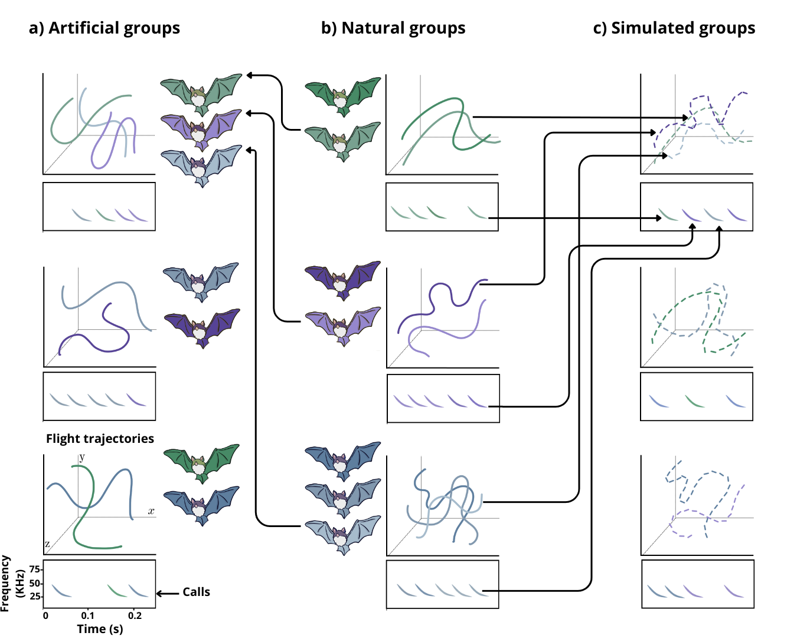
Fig. 1. Schematic of the experimental design used to assess group flight and calling coordination across different group conditions. Exemplary artificial (a) and natural (b) groups are shown next to a schematic 3-D flight trajectory and a spectrogram of the vocal activity with multiple inquiry calls. Natural group membership is depicted by color tonality and the trajectories and calls from a given individual match its color. Artificial groups were composed by temporarily combining individuals from different natural groups (depicted by arrows from natural to artificial group bats) while simulated groups (c) were digitally created by combining flight trajectories and calling activities collected from individuals in natural group trials (illustrated by the arrows from the trajectories and calls from natural to simulated groups).

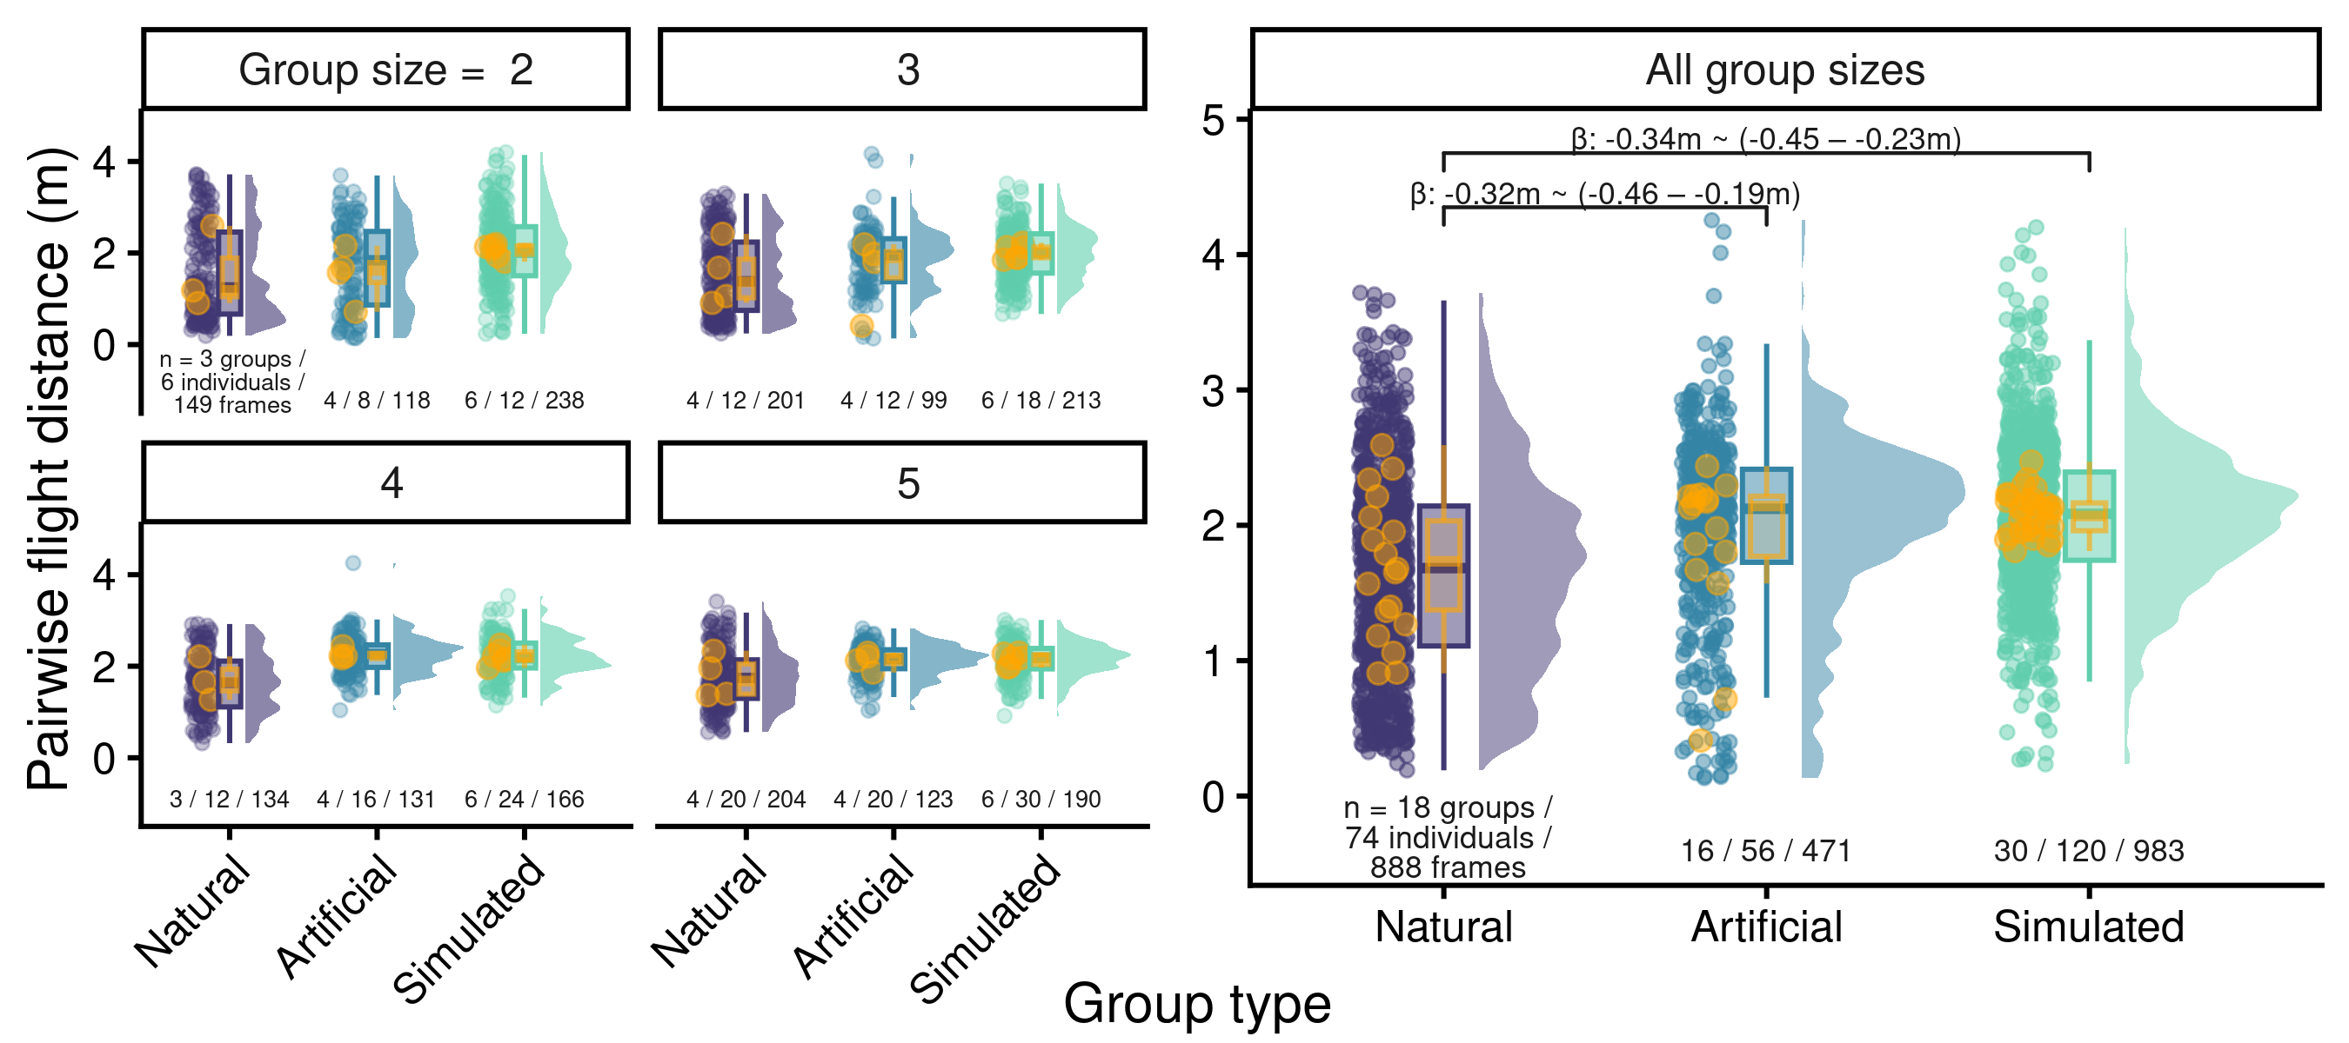Fig. 2. Raincloud plot showing the jittered pairwise distance among individuals per frame and the associated boxplots (median, interquartile range and overall range) and half violin plots, by group flight type (horizontal axis) and group size (panels). For simplicity, data for groups of six individuals are not shown. The right panel shows aggregated data for all group sizes. Yellow points show the mean pairwise distance per group with their distribution represented by overlaid yellow boxplots. Brackets above boxplots in the right panel indicate statistically detectable differences with effect size and 95% uncertainty intervals (in m). Sample sizes for groups and individuals are shown underneath each boxplot. Full model structure and results are available in the supplementary materials.

Synchronising actions plays an important role in reducing predation risk across a range of contexts. For example, breeding groups of birds often synchronise their provisioning by approaching the nest together to reduce nest visitation rates and thus avoiding detection of nest location by predators (28, 29). Groups of Spix’s disc-winged bats face this same challenge on a daily basis, as they require first finding a suitable new leaf in which to roost and then coordinating their entry to reduce the chances of detection by a range of avian and mammalian predators. Placing a furled leaf of Heliconia sp. or Calathea lutea at random positions (Figure 3 a-c) within the flight cage and measuring the time from release into the flight cage until entering the leaf confirmed that natural (familiar) groups were substantially more synchronised than artificial (unfamiliar) groups, with the intervals between successive bats entering the leaf less than half the interval from unfamiliar groups (Figure 3d). We also created simulated groups by combining the entry times of solitary bats finding and entering the leaf (Figure 3c) to gain an insight into the size of the effect of familiarity relative to the benefits from grouping alone. We found that the time between successive entries in familiar groups was less than one quarter the time expected from simulated groups (Figure 3d). This confirms that coordination in this collective task is substantially greater when bats are familiar rather than unfamiliar, and that this effect is over-and-above the benefits of grouping alone.

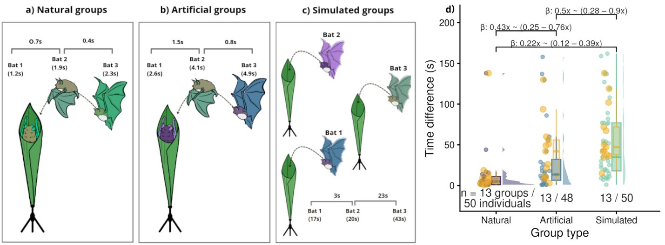
Fig. 3. Scheme of the experimental design to assess roost entry synchrony. Synchronization was quantified as the time lapse between successive individuals when entering the roost. Artificial groups (b) were composed by individuals from different natural groups (a) while simulated groups (c) were digitally created by combining entry times from single individual trials. d) Raincloud plots showing the time difference (s) between successive individuals entering a roost. Jittered points represent individual-level observations, with associated boxplots (median, interquartile range, and overall range) and half-violin plots shown for each group flight type. Yellow points indicate group-level mean time differences, with their distribution summarized by overlaid yellow boxplots. Brackets above boxplots denote statistically detectable differences between group types for the time between successive entries, with effect sizes and 95% uncertainty intervals expressed as fraction relative to the larger time span. Sample sizes for groups and individuals are shown below each boxplot. Full model structure and results are available in the supplementary materials.

Maintaining close spatial cohesion plays an important role in allowing bats to remain together while navigating the dense rainforest and finding roosts. Such precise coordination—in both space and time—relies on effective communication. Communication plays a central role in the performance of human teams (13, 30, 31) and has been linked to increased familiarity (13, 32). However, complex environments—such as rainforests—introduce barriers to effective communication. Fish schools that experience reduced access to visual information, such as in turbid waters, increases cohesion (33) but make slower and less accurate decisions (34), while ants deposit (and rely more on) pheromones in low-light conditions (35, 36). Birds, which have access to both visual and vocal communication systems, are more likely to switch to making acoustic alarm calls when in longer than when in shorter grass (37). Spix’s disc-winged bats have limited visual information both due to vegetation density and due to flying in the dark, but employ a dual call system for coordinating movements and locating roosts. Flying individuals constantly emit ultrasonic inquiry calls while searching for a roost, which are typically answered by response calls from individuals already inside the roost (38). However, a challenge for acoustic communication is that it can easily suffer from information masking or signal jamming (39). This ‘cocktail party effect’ (40–42) arises when many individuals are trying to vocalise simultaneously.

Mitigating the cocktail party effect requires coordinating the delivery of inquiry calls to minimize temporal overlap without compromising the overall vocal output to maintain sufficient information transmission. We recorded calls of solitary bats, natural (familiar) groups and artificial (unfamiliar) groups, applying individual call identification models in group settings to obtain data on call rates. We found distinct differences in how bats called in natural versus artificial groups. Both natural and artificial groups had lower call overlap than expected by chance (simulated groups created by combining solitary flights; Figure 4a), indicating active avoidance of signal jamming at the group level. This seems to be achieved by adjusting calling rates at the individual level, as call rates per bat during group flights were lower than those in solo flights (Figure 4b). However, group-level call rates (ADD EXPLANATION HERE?) by natural groups were nearly twice as high as the call rates by artificial groups (and similar to those of solitary individuals, Figure 4c), suggesting that familiar groups can produce a collective signal that maintains a higher level of acoustic information than unfamiliar groups.

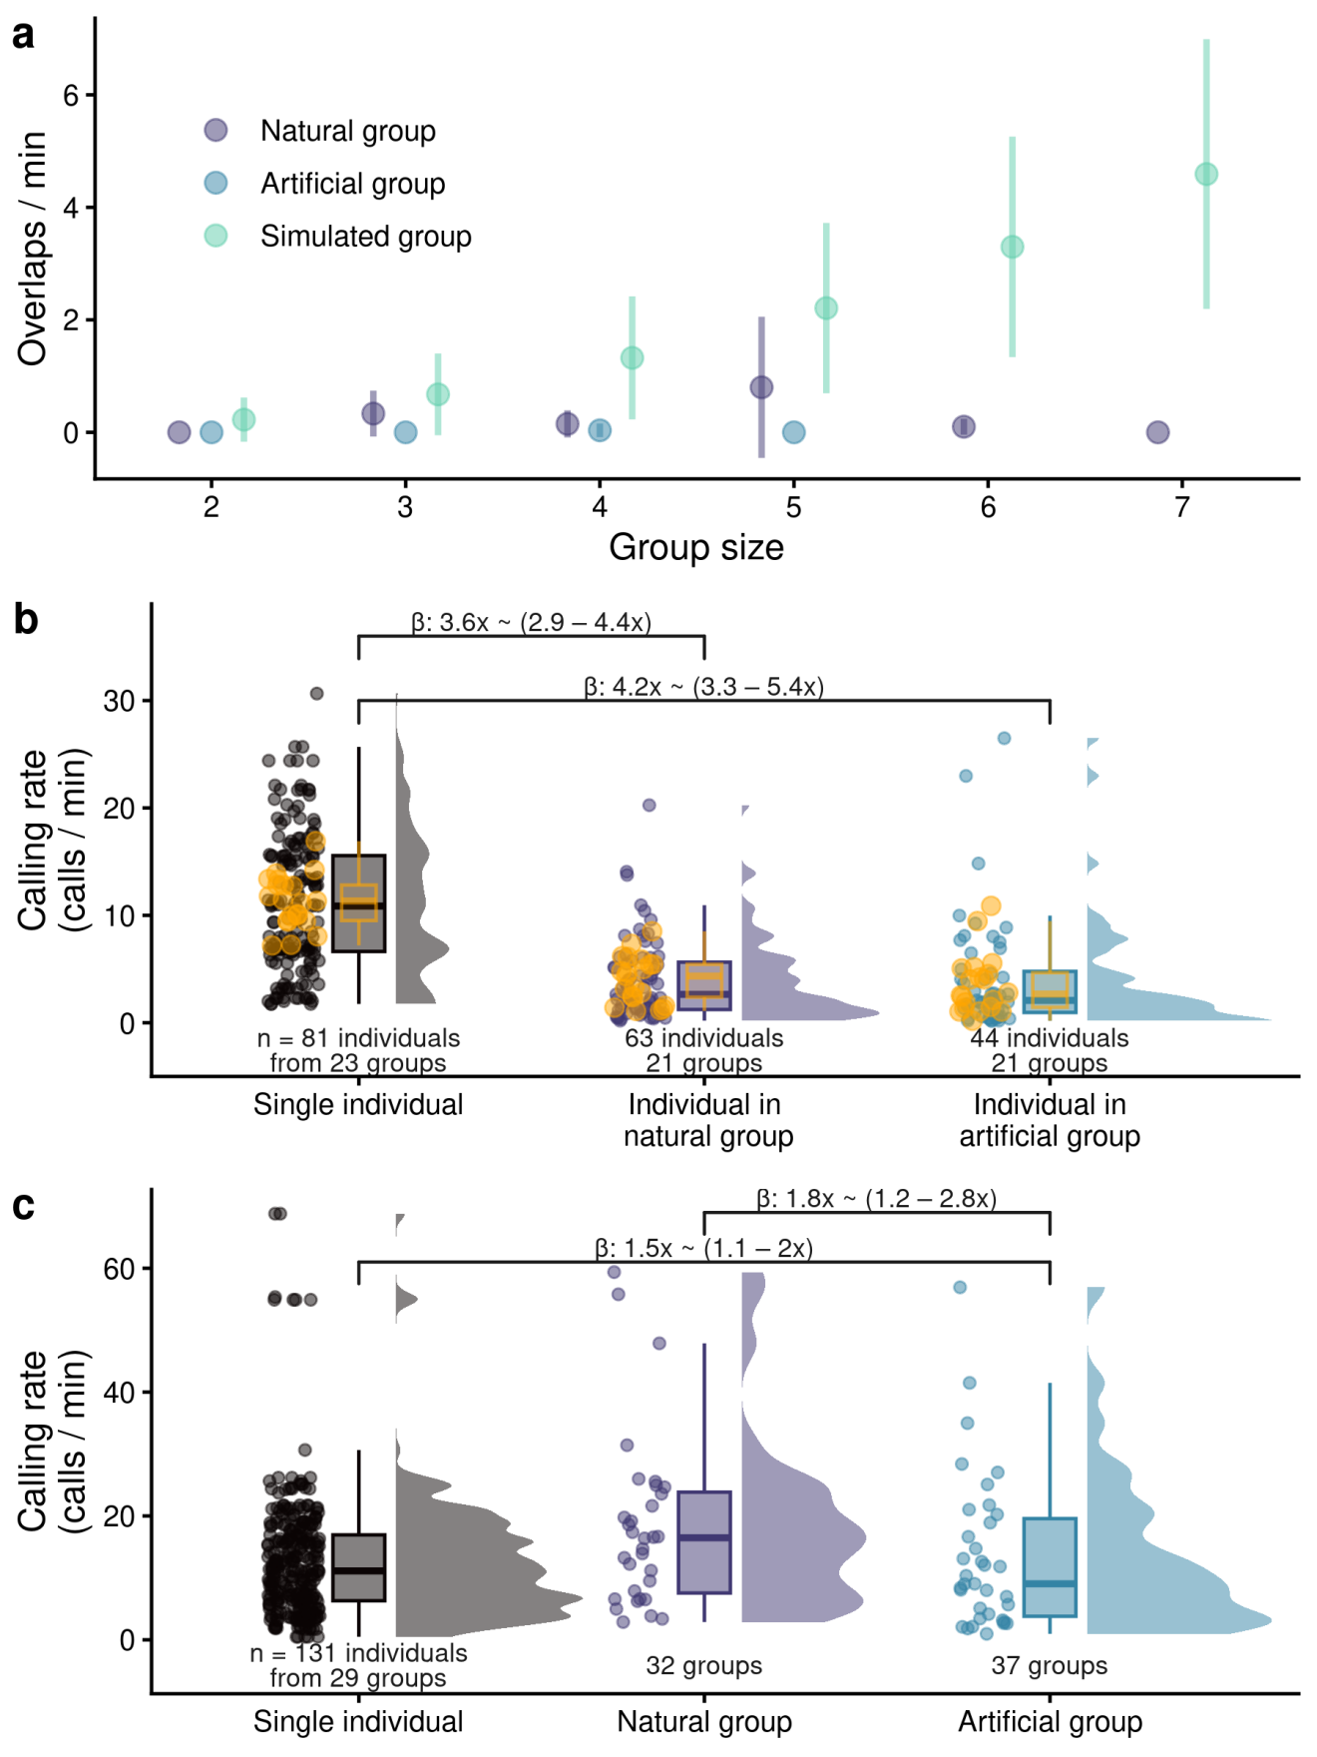
Fig. 4. Vocal coordination and familiarity. a) Average number of inquiry call overlaps in group flights. Simulated values were obtained from 1000 iterations of a custom routine that combined single individual calling data from solo flights. b) Individual inquiry call rate for individuals in solo flights vs call rates of individuals in natural and artificial groups. c) Individual inquiry call rate for single individuals in solo flights vs group-level call rates from natural and artificial groups. Data in b) and c) is shown as raincloud plots of raw data points, boxplots (median, interquartile range and overall range) and half violin plots. Brackets above boxplots indicate statistically detectable differences with effect size and 95% uncertainty intervals as multiplicative differences in calling rate. Sample sizes for groups and individuals are shown underneath boxplots. Yellow points show the mean call rate per group with their distribution represented by overlaid yellow boxplots. Full model structure and results are available in the supplementary materials.

The distinct differences in how natural and artificial groups performed at solving an ecologically relevant task highlights the important contribution of familiarity to collective behaviour by non-human animals. The benefits of familiarity appear to arise specifically through more effective communication, as previously found in human groups (13, 32). In addition, unfamiliarity itself can impose costs: groups of strangers often function less efficiently because individuals must devote attention to evaluating and predicting the behaviour of unfamiliar partners, a cognitively demanding task that can detract from coordination (43, 44). The importance of familiarity and its role in facilitating communication and coordination in various collective tasks that we have uncovered in this study is likely to have widespread importance among social animals. Maintaining cohesion, precisely coordinating actions, and making synchronous collective movements, underpins many ecological processes ranging from reproductive ecology (43, 45–48) through to migration (49–51) that are frequently undertaken in familiar groups. Our findings therefore extend the concept of “team familiarity” beyond humans, showing it to be a general principle of collective life. By demonstrating that even small bat societies rely on familiarity to succeed in critical ecological challenges, this work highlights a common thread linking human collaboration with the collective strategies that shape animal societies across taxa.

Supplementary materials: Familiarity enhances efficiency in complex collective tasks

Methods
Group capturing
Our research was carried out at the Barú Biological Station in southwestern Costa Rica. We searched for bats within the developing tubular leaves of Calathea lutea and Heliconia imbricata, which are species commonly used by Spix's disc-winged bats for roosting (25, 52). When bats were found, we captured all group members and placed them inside a cloth holding bag. All individuals older than 2 months were marked with transponders (Mini HPT8 Transponder; Biomark Inc., ID, U.S.A.) and scanned using Biomark's HPR Lite reader to individually identify them. Transponders were injected subcutaneously in the mid-dorsal area after cleaning the needle, the transponder and the injection area and its surroundings with an antiseptic (Chlorhexidine Gluconate). Groups were brought to the field station to conduct experiments. After experiments, we provided water and mealworm larvae to all individuals. Bats were returned to their capture sites by gently placing them in their original roost.
Experiments
All experiments were conducted in a flight cage (9 x 4 x 3 m; double white cloth) during the daytime as the behavior under study, the coordination of flight among all group members to locate roost sites, has only been observed during this time, not at night (38, 53).
Group flight coordination
Experimental design

We released all members of a natural group (bats captured while sharing the same roost) inside a large flight cage (9 x 4 x 3 m) and allowed them to fly freely for 5 min. Flight experiments were also conducted for artificial groups that were created by combining bats from all natural groups captured in a given day. To identify and differentiate between individuals in each experiment, we used nontoxic colored fluorescent powders (MagruderColor Company), which were applied to the dorsal and ventral areas of each bat. The creation of new (artificial) groups was done with a custom programmatic routine that maximized the number of individuals involved in the experiment while enforcing the following conditions: 1) group size of 2-5 individuals, 2) all individuals in a group must come from different natural groups, 3) no color must be repeated in a group, 4) sex ratio as close as possible to 50:50 (23), 5) individuals are only used in a single artificial group.

We videotaped group flight experiments using an array of three GoPro cameras (7 Hero) positioned at the margin of the cage interior. Videos from the three cameras were synchronized with the open-source 3-D computer graphics software Blender. We then analyzed the videos, annotating all frames in 5 s sections in which all individuals were visible and estimated the position in three-dimensional (3-D) space for each individual with the software Argus (54). The 3-D position data allowed us to reconstruct individual flight trajectories, which were used to compute the pairwise inter-individual Euclidean distances (m) at each time step. In addition, we generated simulated group flights by combining the flight trajectories of individuals from different trials representing the expected group flight pattern in the absence of coordination. Individual 3-D flight trajectories were resampled and combined to construct simulated groups using a Monte Carlo resampling procedure. For each simulated group, individual trajectories were randomly selected without replacement from a pool of recorded single-bat trajectories from group flights and assigned to groups of 2-5 individuals, the most commonly observed group sizes. To ensure temporal alignment among individuals within a simulated group, all trajectories were truncated to the shortest common duration. The aligned trajectories were then combined into a single group-level data set. This procedure was repeated 30 times in order to generate variation in the individual composition of simulated groups, which allowed us to propagate the uncertainty due to the stochasticity of the randomization procedure into our statistical inference (see below).

Statistical analysis

We fitted Bayesian multilevel (mixed effects) regression models to evaluate differences in flight coordination between natural, artificial, and simulated groups. To account for stochasticity in the construction of simulated groups, we generated 30 independent datasets differing in the composition of simulated group trajectories. For each dataset, the corresponding natural and artificial group data were added, and a regression model was fitted. In all models, the mean pairwise Euclidean distance between individuals from each video frame was used as the response variable, modeled with a Gaussian error distribution. We included group type (natural, artificial, or simulated) and group size as predictors. Group identity was included as a varying intercept effect (e.g., random effect) to account for the non-independence of observations. Because distance measurements were temporally ordered, residual temporal autocorrelation was modeled using an autoregressive moving average correlation structure, with group identity as the grouping variable. This structure accounts for short-term temporal dependence between successive frames during flight. These 30 models were then combined into an averaged single model for statistical inference (explained below).
Roost entry synchrony

As bats approach a new roost, they typically enter in rapid succession. This behavior is also exhibited in captivity as groups have previously been shown to readily enter available roosts under experimental conditions (55, 56). To evaluate group coordination and the effect of familiarity in this behavior we conducted roost entry experiments in flight cages, placing a furled Calathea lutea leaf at a random position. Bats were allowed to fly freely until they entered the roost or until the trial reached a 5-minute limit; trials that reached this maximum were excluded from analysis. All roost entry trials were video recorded with a GoPro camera (7 Hero) positioned approximately 4 m from the roost. Videos were manually annotated to register the time at which each individual entered the roost.

Experiments were performed on both natural and artificially formed groups to assess the role of familiarity in synchronization. Artificial groups were created using the same procedure as in the flight coordination trials. Furthermore, to establish baseline entry times in the absence of social coordination, we also conducted trials with single individuals from natural groups. These trials were used to generate simulated groups, representing the expected distribution of entry times if individuals entered the roost independently, i.e., according to their intrinsic latency to enter rather than in response to the behavior of groupmates.

We used a Monte Carlo resampling procedure to randomly combine the entry times of trials from single individuals in order to simulate group entries, thereby generating null expectations under the absence of synchronization. For each simulation replicate, individuals were selected without replacement from the pool of recorded single-bat roost entry times and assigned to groups of 2-5 individuals, using a fixed random seed to ensure reproducibility. For each simulated group, roost entry times from the corresponding individual experiments were combined and ordered chronologically to reconstruct a group-level entry sequence. Inter-individual entry time differences were then calculated to quantify temporal coordination during roost entry. Simulated group entries were combined with empirical group roost entry data and used in subsequent statistical analyses.

Statistical analysis

We fitted Bayesian multilevel regression models to evaluate differences in roost entry synchronization between natural, artificial, and simulated groups. To account for stochasticity in the construction of simulated groups, we generated 30 independent datasets differing in the composition of simulated groups. For each dataset, the corresponding natural and artificial group data were added, and a regression model was fitted. In all models, the log-transformed inter-individual entry time difference was used as the response variable, modeled with a Gaussian error distribution, and group type (natural, artificial, or simulated) as the predictor. Predictors included group type and group size. Group identity was included as a varying intercept effect (e.g. random effect) to account for the non-independence of observations. These 30 models were then combined into an averaged single model for statistical inference (explained below).
Vocal coordination

Spix’s disc-winged bats exhibit a dual call communication system in which individuals looking for their group roost broadcast inquiry calls that are replied with response calls from individuals already in the roost (38). We recorded inquiry calls of both natural and artificial groups during flight coordination trials in order to assess vocal coordination. We also conducted single individual flights for all bats in group flight trials, in which bats flew freely for 5 min and their calls were recorded. These single individual trails were subsequently used for individual identification analyses (see below). Calls were recorded using an array of 4 Omnidirectional Electret Ultrasound Microphones (Knowles FG-O, Avisoft Bioacoustics, Glienike/Nordbahn, Germany) plugged into an Avisoft UltraSoundGate 416H connected to a laptop computer running Avisoft-Recorder software (sampling rate of 500 kHz, 16-bit amplitude resolution). Microphones were evenly spaced across the cage floor to ensure uniform acoustic sampling. Recordings were resampled to a 90 kHz sampling rate (i.e. a Nyquist frequency of 45 kHz) prior to analyses as all recorded calls showed a frequency range below 45 kHz.

We used a semi-supervised approach to detect the temporal occurrence of inquiry calls in the recordings. Template matching was performed by cross-correlating Mel frequency spectrograms (40 warped spectral bands, 12 cepstra, 512 sample window length, 12-42 kHz bandpass filtered) using the R package ohun (v1.0.5; (57)). Briefly, this method estimates the similarity of a sample sound (template) across an entire recording by correlating power values from the corresponding time-frequency matrices entailed by the spectrograms using a sliding window approach. Values exceeding a correlation threshold are classified as detections. Template selection was based on detection performance assessed for a set of five templates representing structural variation in calls, evaluated on a subset of manually annotated recordings. The template yielding the highest F1 score was subsequently used for template matching across the full dataset. This procedure was also used to optimize the correlation threshold (r = 30). All detections were visually inspected and curated by removing erroneous detections and adding missing calls. Start and end times for all detections were then manually adjusted, as the template-matching algorithm estimates call location as a single time point rather than explicit temporal boundaries.

Identifying individuals in group flights

We built automated classification models to identify the calling individual for each call produced during group flights. Supervised random forest classifiers (58), implemented in the R package ranger (59), were trained separately for each subset of individuals within a group flight trial (natural or artificial). Training datasets were generated by combining calls from group members recorded during single-individual trials. Low-quality calls were excluded from the analysis (signal-to-noise ratio < 1 dB). Random forest was preferred over more commonly used alternatives (e.g., discriminant function analysis) because it accommodates non-monotonic relationships, is robust to outliers, and performs well with high-dimensional data (58, 60). Structural variation in calls was quantified using six sets of acoustic features: (i) spectro-temporal power distribution features (13 features), (ii) dominant frequency contour descriptors (8 features), (iii) statistical descriptors of Mel-frequency cepstral coefficients (178 features), (iv) linear-frequency spectrogram cross-correlation (10 features), (v) Mel-frequency spectrogram cross-correlation (10 features), and (vi) dynamic time warping similarity of dominant frequency contours (10 features). The latter three approaches produce similarity matrices, which were reprojected into a ten-dimensional space representing acoustic structure using classical multidimensional scaling. Acoustic analyses were conducted with the R package warbleR (v1.1.37; (61)) with a hamming window function, 20% window overlap and 300 sample fast Fourier transformation, which resulted in a frequency resolution of 300 Hz and a time resolution of 2.67 ms.

We evaluated the classification performance of all possible combinations of individual acoustic feature sets across all models and identified the highest-performing feature set as the combined dataset including all features except dynamic time warping similarity of frequency contours. The selected features were then used to train all classification models. Models were then applied onto the detected calls from group flight recordings to identify calling individuals. To avoid biases arising from unequal numbers of calls per individual, the training data were first balanced by randomly subsampling an equal number of calls from each individual, corresponding to the minimum sample size across individuals. Random forest models were then fitted with individual identity as the response variable and acoustic features as predictors. Models were trained using 1,000 trees, a minimum node size of 1 and 15 variables per split, sampled with replacement. The predicted caller identity was assigned as the individual with the highest class probability. Model performance was measured using the out-of-bag (OOB) error, an internal cross-validation measure inherent to random forest classifiers. All models were trained using a fixed random seed to ensure reproducibility and the performance of the models were compared against a null expectation generated by permuting individual identity labels. Only models that outperformed the null model were used in further analysis.

We simulated group calling in the absence of coordination using a Monte Carlo resampling procedure. For each simulation run, entire solitary call sequences were sampled without replacement and assigned to a group. For each simulated group, the inquiry call times from the sampled solitary flights were combined to form a synthetic group calling sequence, thereby preserving the original temporal structure of calls within individuals. This procedure was repeated for each group size, producing a set of simulated group calling datasets in which call timing reflected individual calling patterns but lacked any coordinated temporal structure among individuals. The simulation was repeated for 1000 iterations, using a fixed random seed to ensure reproducibility. For each of the 30 simulated datasets, simulated data were combined with the corresponding observed data, yielding matched datasets containing both empirical and simulated observations.

Statistical analysis

To assess the effect of familiarity on individual vocal behavior during group flights, we fitted a Bayesian multilevel regression model to individual inquiry calling rates using the R package brms (62). The number of calls produced by each individual was modeled as a rate, with flight duration included as an offset. Call counts were assumed to follow a negative binomial distribution to account for overdispersion. Models included flight type (solitary, natural group, artificial group) and group size as fixed effects. Individual identity was included as a random intercept to account for repeated measures.

A similar Bayesian multilevel model was fitted to compare calling rates between solitary and overall group flights. Inquiry call counts were modeled as rates using flight duration as an offset and assumed to follow a negative binomial distribution. Fixed effects included flight type and group size. To account for repeated observations within groups and heterogeneity in group responses, group identity was included as a random effect with varying intercepts and flight-type–specific slopes, allowing the effect of flight type to vary among groups. Random slopes were specified because individual vocal behavior was likely to vary among groups in both baseline levels and responsiveness to flight type.

Additional Bayesian regression models were used to examine differences in call overlap occurrence among natural and artificial groups against those from simulated group flights. Call overlap counts were modeled as rates by including flight duration as a log offset. Simulated groups were specified as the reference level to facilitate direct comparison with empirically observed group flights. Models were fitted using a Poisson likelihood with a log link. To account for stochasticity in the construction of simulated group calling, we fitted a regression model on each of the 30 simulated datasets. The models were then combined into an averaged single model for statistical inference (explained below).

Further details on regression models

Model fitting

Regressions were run in Stan (63) through the R package brms (62), using Hamiltonian Monte Carlo with conservative tuning parameters to ensure convergence. Models were run for 10 000 iterations, using the first half as warm-up. Across all Bayesian models, we used weakly informative priors chosen to regularize estimation while remaining biologically agnostic. Intercepts were assigned Normal priors centered at zero with moderate scale (Normal(0, 1–1.5)), reflecting plausible baseline rates on the link scale without constraining them tightly. Fixed-effect coefficients were given Normal(0, 0.5–1) priors to discourage unrealistically large effects while allowing meaningful differences among flight types and group sizes. Variance parameters for group- or individual-level random effects were modeled with Student-t(3, 0, 1) priors, providing robustness to occasional larger variability while shrinking small effects toward zero. Correlations among random effects, where included, were assigned LKJ(2) priors to mildly favor low to moderate correlations without excluding stronger associations. For count models, overdispersion parameters in negative binomial models were given Exponential(1) priors, favoring modest overdispersion but allowing heavier tails when supported by the data.

Effect sizes were computed as median posterior estimates and 95% uncertainty intervals (UI) as the highest posterior density interval. When response variables were modeled using a log link (negative binomial or Poisson distributions), effect sizes were converted to multiplicative differences by exponentiating posterior estimates and their uncertainty interval. The bulk and tail effective sample sizes were kept above 1000 per chain for all parameters, ensuring precise estimates, and the number of divergent transitions was kept below 1%, confirming the sampler explored the posterior distribution effectively. We plotted the distribution of posterior estimates for all chains for visual evaluation of model performance. In order to assess the independence of the posterior samples, we also estimated the potential scale reduction factors for checking model convergence (kept below 1.05 for all parameter estimates). Predictors in which UI did not include zero (or did not include one for those presented as multiplicative differences) were regarded as having an effect on the response variables. Whenever group size was included as a predictor it was treated as an ordered factor and modeled as a monotonic effect, allowing the response variable to change consistently with increasing group size without assuming linearity (64). Pairwise contrasts among group types were computed directly from the posterior distributions of the fitted model. For each contrast, we report the posterior mean and the 95% UI of the resulting posterior distribution.

We evaluated the predictive performance of all models, measured by the Leave-one-out Information Criterion (65) in the R package loo (v2.9.0; (66)), by comparing each model against its corresponding null model (i.e., a model without the group type predictor). Models were compared using the expected log predictive density (ELPD). Only models that outperformed their null model (i.e., their difference was higher than twice the ELPD standard error) were further considered for statistical inference.

Posterior predictive checks (67) were used to evaluate model adequacy by comparing observed data to data simulated from the posterior predictive distribution. For each fitted model (or average model fit, see below), multiple replicated datasets were generated by drawing from the posterior (default = 30 draws). Model fit was assessed visually using several complementary diagnostics. First, density overlay plots compared the distribution of observed responses to those of replicated data, either pooled across all observations or stratified by a grouping factor when provided. Second, posterior predictive distributions of summary statistics were examined by comparing observed and replicated means, again optionally by group. Third, scatter plots of observed versus posterior‐averaged predictions were used to evaluate overall agreement between empirical and predicted values. Finally, two-dimensional posterior predictive checks were used to assess joint behavior of pairs of summary statistics. All posterior predictive plots were inspected to ensure that the observed data fell within the range of variability expected under the fitted models, indicating adequate model fit.
Model averaging for simulated data
Because each simulated dataset represents an equally plausible scenario of simulated group composition, we did not condition inference on a single fitted model. Instead, we combined posterior distributions across all fitted models using LOO-based posterior model averaging. This procedure weighs the posterior contribution of each model by its out-of-sample predictive performance, thereby integrating over uncertainty associated with the stochastic simulation process.
The resulting averaged posterior distribution was used to summarize parameter estimates and uncertainty for all fixed effects. This approach yields a single posterior representation that marginalizes over simulation uncertainty. To quantify differences among levels of categorical predictors, we computed posterior contrasts from the averaged posterior distribution, which were summarized using posterior means and UI similar to effect sizes.

Results
Group flight coordination
We assessed whether the pairwise distance between individuals in group flight varied between group types (natural, artificial and simulated). The model including group type and group size as predictors outperformed the corresponding null model (ΔELPD = 22.12, SE = 7.19). Posterior estimates showed that flight coordination differed among group types. Relative to natural groups (intercept estimate = 1.49 m, 95% UI: 1.37–1.61 m), both artificial (β = 0.32 m, 95% UI: 0.19 – 0.46 m) and simulated groups (β = 0.34 m, 95% UI: 0.23 – 0.45 m) exhibited higher distances among individuals. In contrast, pairwise flight distance did not differ credibly between artificial and simulated groups (β = 0.02 m, 95% UI: 0.12 – 0.15 m). Group size was positively associated with inter-individual flight distance (β = 0.08, 95% UI: 0.05–0.12), indicating that spacing between individuals increased with increasing group size.
Roost entry synchrony
Variation in roost entry synchrony was evaluated by comparing the time lapse between successive entries between natural, artificial and simulated groups. The model predicting time lapses that inluded group type and group size, outperformed its corresponding null model (ΔELPD = 13.85, SE = 4.16). Roost entry intervals were in natural groups were 0.43× (95% UI: 0.25–0.76x) as long as those in artificial groups and 0.22× (95% UI: 0.12–0.39x) as long as those in simulated groups. Artificial groups also differed from simulated groups, exhibiting entry intervals 0.50× (95% UI: 0.28–0.90) as long. Entry time lapses between individuals were also affected by group size: the mean entry time lapse between individuals increased by a factor of 1.36 per unit increase in group size (95% UI: 1.05 – 1.73x).
Vocal coordination
Individual vs group calling rates. We evaluated whether groups produced calling rates similar to those of single individuals. The model including group type and group size as predictors was clearly favor over the null alternative based on predictive performance (ΔELPD = 25.65, SE = 10.48). There was no detectable difference between calling rates of individuals in single flights and group calling rates in natural groups (β: 0.79 times lower; 95% UI: 0.61–1.03x). In contrast, calling rates were reduced in artificial groups. Solo individuals called 1.47 times more frequently than artificial groups (95% UI: 1.07–2.03x), and natural groups called 1.85 times more frequently than artificial groups (95% UI: 1.23–2.79x). Group size had no detectable effect on calling rate (β: 1.01 times higher per unit increase; 95% UI: 0.91–1.10x).
Individual calling rates in solo vs. group flights. We evaluated whether individuals modified their calling rates when being of part of a group compared to when flying individually. The model including flight type and group size as predictors show a substantial improvement in predictive performance over the null alternative (ΔELPD = 81.77, SE = 12.48). Calling rates from single individuals were 3.56 times higher than those from individuals in natural group flights (95% UI: 2.86–4.42×) and 4.24 times higher than those from individuals in artificial flights (95% UI: 3.32–5.38×). Individuals in natural and artificial groups produced similar calling rates (1.20 times higher in natural groups; 95% UI: 0.89–1.59×). Group size showed a negative effect on individual calling rate (β: 0.79 times lower per unit increase in group size; 95% UI: 0.79–0.99x).
Calling overlap. The number of call overlaps during natural and artificial group flights were compared to those from simulated groups. Predictive performance strongly favored the model including group type and group size as predictors over the null alternative (ΔELPD = 211.07, SE = 54.18). Simulated groups produced 10.37× as many overlaps (95% UI: 2.56–16.7×) as natural groups and 61.5× as many overlaps as artificial groups (95% UI: 7.31–15.15×). Group size had a positive effect on overlap rate (β = 1.56× per unit increase in group size; 95% UI: 1.41–1.76×).

References

1. C. R. Reid et al., Proc. Natl. Acad. Sci. U.S.A. 112, 15113–15118 (2015).
2. T. D. Seeley, Behav Ecol Sociobiol. 53, 417–424 (2003).
3. M. J. Hansen, P. Domenici, P. Bartashevich, A. Burns, J. Krause, Biological Reviews. 98, 1687–1711 (2023).
4. A. Berdahl, C. J. Torney, C. C. Ioannou, J. J. Faria, I. D. Couzin, Science. 339, 574–576 (2013).
5. R. E. Kenward, The Journal of Animal Ecology. 47, 449 (1978).
6. W. Cresswell, Animal Behaviour. 47, 433–442 (1994).
7. J. E. Herbert-Read et al., Proc. Natl. Acad. Sci. U.S.A. 108, 18726–18731 (2011).
8. M. Ballerini et al., Animal Behaviour. 76, 201–215 (2008).
9. F. Montanari, G. Silvestri, E. Gallo, Journal of Sport Management. 22, 701–716 (2008).
10. B. Muskat, A. Anand, C. Contessotto, A. H. T. Tan, G. Park, Human Resource Management Review. 32, 100892 (2022).
11. K. Joshi, J. Hernandez, J. Martinez, K. AbdelFattah, A. K. Gardner, The American Journal of Surgery. 215, 243–249 (2018).
12. D. H. Gruenfeld, E. A. Mannix, K. Y. Williams, M. A. Neale, Organizational Behavior and Human Decision Processes. 67, 1–15 (1996).
13. N. Oesch, R. I. M. Dunbar, Ethology. 124, 483–495 (2018).
14. R. S. Huckman, Harvard Business Review. 91, 27–29 (2013).
15. R. S. Huckman, B. R. Staats, D. M. Upton, Management Science. 55, 85–100 (2009).
16. S. Davis, R. Lukeman, T. M. Schaerf, A. J. W. Ward, R. Soc. open sci. 4, 170312 (2017).
17. L. E. Nadler, M. I. McCormick, J. L. Johansen, P. Domenici, Commun Biol. 4, 897 (2021).
18. W. Swaney, J. Kendal, H. Capon, C. Brown, K. N. Laland, Animal Behaviour. 62, 591–598 (2001).
19. N. Atton, B. J. Galef, W. Hoppitt, M. M. Webster, K. N. Laland, Proc. R. Soc. B. 281, 20140579 (2014).
20. A. Strandburg-Peshkin, D. R. Farine, I. D. Couzin, M. C. Crofoot, Science. 348, 1358–1361 (2015).
21. D. Papageorgiou, B. Nyaguthii, D. R. Farine, Commun Biol. 7, 95 (2024).
22. G. Chaverri, Behavioral Ecology and Sociobiology. 64, 1619–1630 (2010).
23. M. J. Vonhof, H. Whitehead, M. B. Fenton, Animal Behaviour. 68, 507–521 (2004).
24. J. S. Findley, D. E. Wilson, Journal of Mammalogy. 55, 562–571 (1974).
25. M. J. Vonhof, M. B. Fenton, Journal of Tropical Ecology. 20, 291–305 (2004).
26. L. J. Morrell, R. James, Behavioral Ecology. 19, 193–201 (2008).
27. J. Krause, G. D. Ruxton, Living in groups (Oxford University Press, New York, 2002).
28. N. J. Raihani, M. J. Nelson‐Flower, K. Moyes, L. E. Browning, A. R. Ridley, Journal of Animal Ecology. 79, 44–52 (2010).
29. K. Bebbington, B. J. Hatchwell, BEHECO. 27, 652–659 (2016).
30. S. L. Marlow, C. N. Lacerenza, J. Paoletti, C. S. Burke, E. Salas, Organizational Behavior and Human Decision Processes. 144, 145–170 (2018).
31. J. R. Mesmer-Magnus, L. A. DeChurch, Journal of Applied Psychology. 94, 535–546 (2009).
32. A. J. King et al., Biol. Lett. 7, 237–240 (2011).
33. H. E. A. MacGregor, C. C. Ioannou, Ecology and Evolution. 13, e10708 (2023).
34. A. C. Chamberlain, C. C. Ioannou, Animal Behaviour. 156, 129–138 (2019).
35. S. Jones et al., Animal Behaviour. 156, 87–95 (2019).
36. J. R. Attwell, thesis, University of Bristol, Bristol, England (2023).
37. C. L. Devereux, E. Fernàndez‐Juricic, J. R. Krebs, M. J. Whittingham, Ibis. 150, 191–198 (2008).
38. G. Chaverri, E. H. Gillam, M. J. Vonhof, Biology Letters. 6, 441–444 (2010).
39. C.-C. Liao, R. D. Magrath, M. B. Manser, D. R. Farine, Phil. Trans. R. Soc. B. 379, 20230184 (2024).
40. J. H. McDermott, Current Biology. 19, R1024–R1027 (2009).
41. M. A. Bee, C. Micheyl, Journal of Comparative Psychology. 122, 235–251 (2008).
42. C.-C. Liao, R. D. Magrath, M. B. Manser, D. R. Farine, Phil. Trans. R. Soc. B. 379, 20230184 (2024).
43. M. A. Strodl, P. Schausberger, Oikos. 122, 1217–1226 (2013).
44. S. W. Griffiths, S. Brockmark, J. Höjesjö, J. I. Johnsson, Proc. R. Soc. Lond. B. 271, 695–699 (2004).
45. M. M. Mariette, S. C. Griffith, Journal of Avian Biology. 43, 131–140 (2012).
46. C. Doutrelant, R. Covas, Animal Behaviour. 74, 739–747 (2007).
47. K. E. Lucia, B. Keane, Behav Ecol Sociobiol. 66, 13–27 (2012).
48. A. Culina, J. A. Firth, C. A. Hinde, Proc. R. Soc. B. 287, 20201554 (2020).
49. P. Byholm, M. Beal, N. Isaksson, U. Lötberg, S. Åkesson, Nat Commun. 13, 1566 (2022).
50. R. Chetverikova, O. Babushkina, S. Galkina, V. Shokhrin, J. Bojarinova, Behav Ecol Sociobiol. 71, 40 (2017).
51. A. Kölzsch et al., Journal of Avian Biology, in press, doi:10.1111/jav.02392.
52. G. Chaverri, T. H. Kunz, PLoS ONE. 6, e28821 (2011).
53. B. K. Montero, E. H. Gillam, Animal Behaviour. 108, 81–89 (2015).
54. B. E. Jackson, D. J. Evangelista, D. D. Ray, T. L. Hedrick, Biology Open. 5, 1334–1342 (2016).
55. M. Sagot, N. Rose, G. Chaverri, Phil. Trans. R. Soc. B. 379, 20230187 (2024).
56. M. Sagot, C. R. Schöner, A. J. Jago, I. Razik, G. Chaverri, Animal Behaviour. 142, 157–164 (2018).
57. M. Araya‐Salas et al., Methods Ecol Evol. 14, 2259–2271 (2023).
58. L. Breiman, Machine Learning. 45, 5–32 (2001).
59. M. N. Wright, A. Ziegler, Journal of Statistical Software. 77 (2017), doi:10.18637/jss.v077.i01.
60. J. J. Valletta, C. Torney, M. Kings, A. Thornton, J. Madden, Animal Behaviour. 124, 203–220 (2017).
61. M. Araya‐Salas, G. Smith‐Vidaurre, Methods in Ecology and Evolution. 8, 184–191 (2017).
62. P.-C. Bürkner, Journal of Statistical Software. 80, 1–28 (2017).
63. Stan Development Team, Stan modeling language users guide and reference manual, version 2.28.0 (2021).
64. P. Bürkner, E. Charpentier, Brit J Math & Statis. 73, 420–451 (2020).
65. A. Vehtari, A. Gelman, J. Gabry, Statistics and Computing. 27, 1413–1432 (2017).
66. A. Vehtari et al., loo: Efficient leave-one-out cross-validation and WAIC for Bayesian models (2025).
67. A. Gelman et al., Bayesian data analysis (CRC Press, Taylor & Francis Group, Boca Raton London New York, Third edition., 2014), Texts in statistical science series.

